Lesson 5 Demo 1
Setting Up Jenkins

Objective: Download and set up the Jenkins app

Tools required: JRE and Jenkins
Note: Jenkins is already installed in your practice labs. Please refer the lab guide for more details.

Steps to be followed:
- Download the Java Runtime Environment
- Download and install the Jenkins app

Step 1: Downloading the Java Runtime Environment
  - Open the terminal.
  - Run sudo apt-get update to update the package lists.
  - Run java -version to verify the installation. It will print the JDK version as shown below:
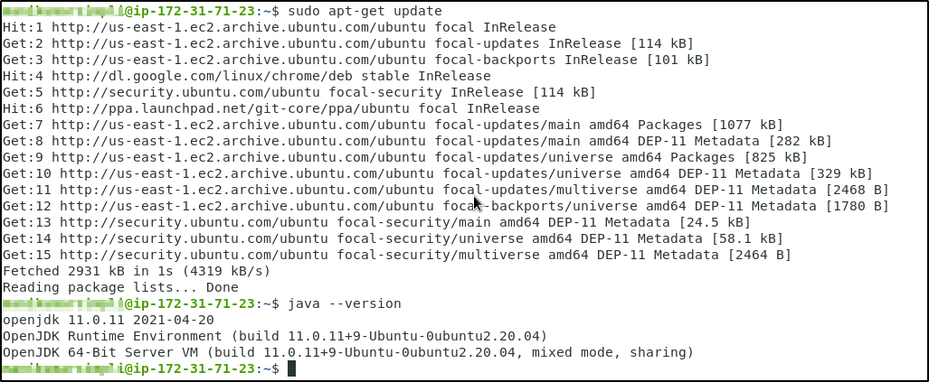

Step 2: Downloading and installing the Jenkins app
  - Open the terminal.
  - Run wget -q -O - https://jenkins-ci.org/debian/jenkins-ci.org.key | sudo apt-key add - to install Jenkins.
  - Run sudo sh -c 'echo deb http://pkg.jenkins-ci.org/debian binary/ > /etc/apt/sources.list.d/jenkins.list' command.
  - Run sudo apt-get update
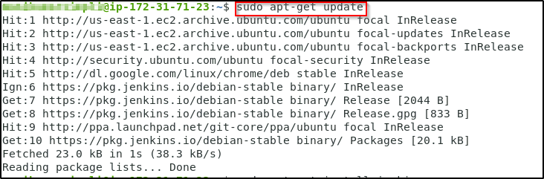
  - Run sudo apt-get install jenkins to install Jenkins.
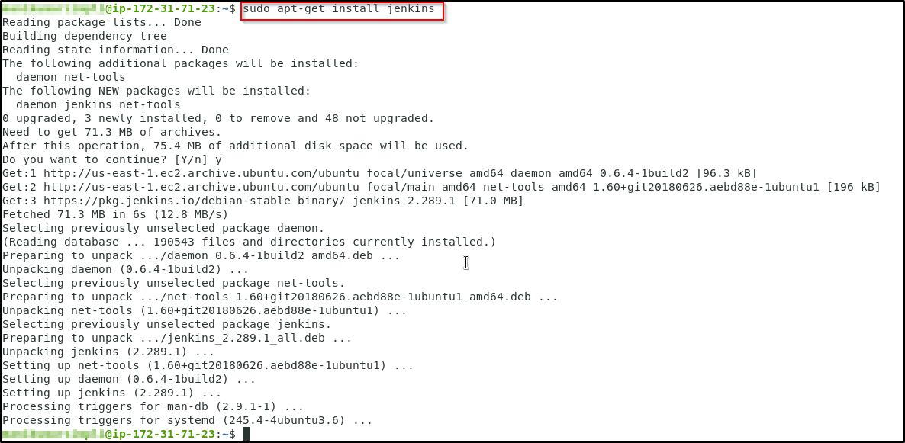

  - Run sudo service jenkins status to check the status of the installation. Once you verify the status as active, you can press Ctrl+z to exit from the process.
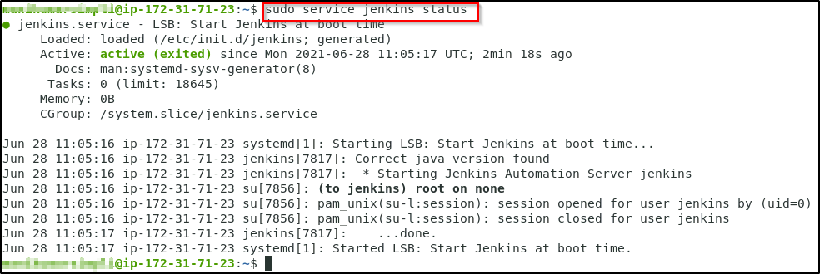

  - Run the following commands to start Jenkins.
sudo systemctl start jenkins
sudo systemctl status jenkins
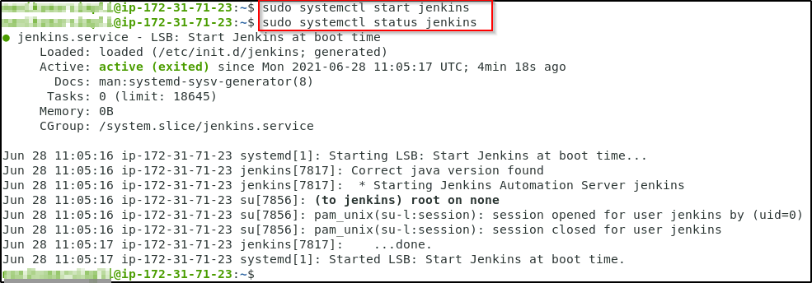

  - Open localhost:8080 in the browser, and you will need to enter the initial password.
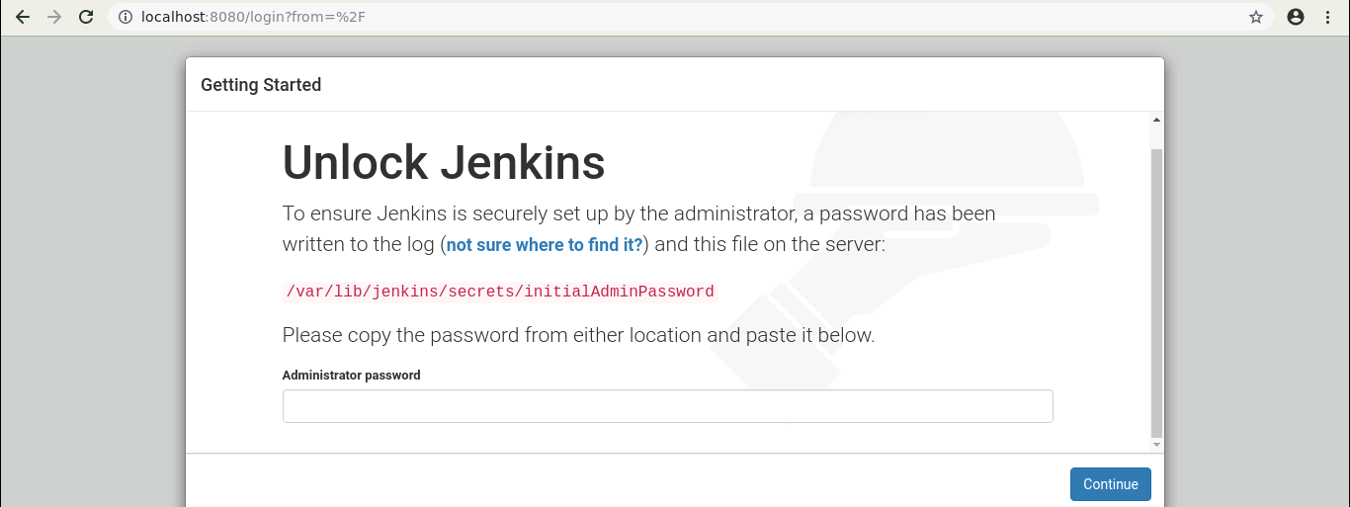

  - In your terminal run the following command:
sudo cat /var/lib/jenkins/secrets/initialAdminPassword

  - Copy this password and paste it on your Jenkins page in the browser.
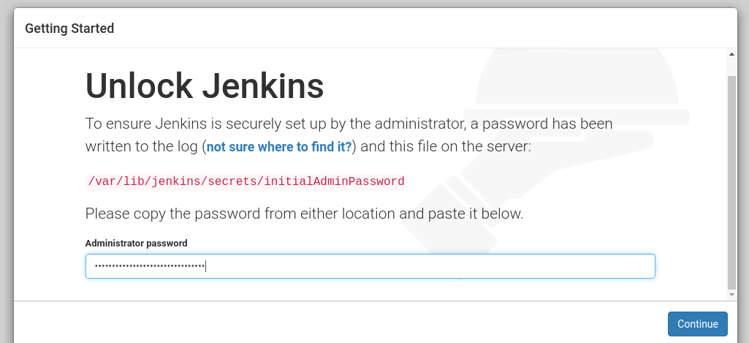

  - Now, click on Install the suggested plugins.
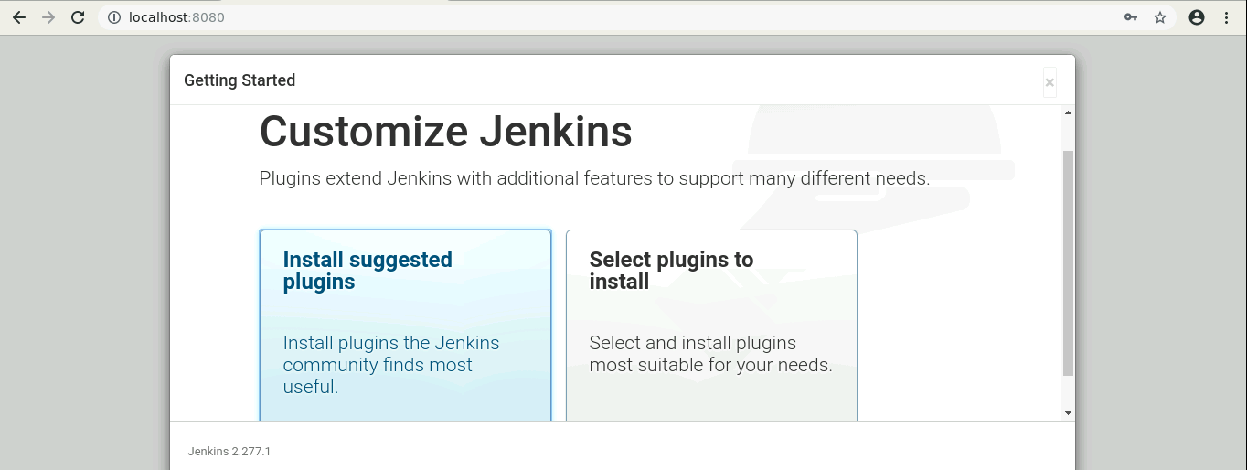

  - You can either create an admin user or skip and continue as admin. Select Skip and continue as admin.
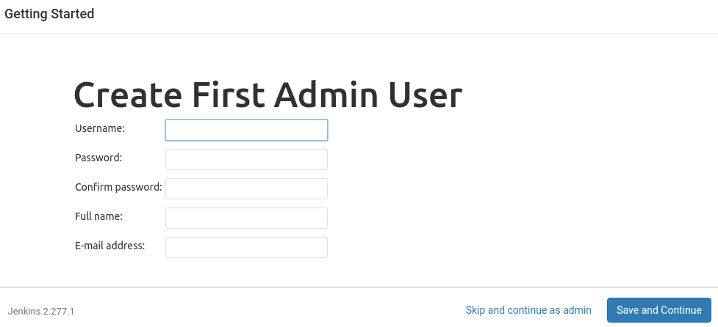

  - In the Instance configuration page, click on the Start using Jenkins button.
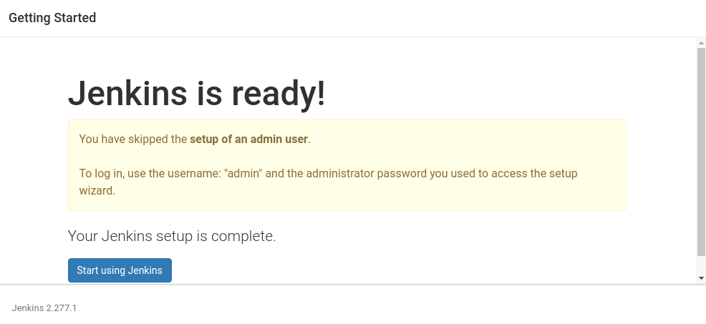

  - Now, you can work with Jenkins as shown in the screenshot below.
